# **Visual Geometry Group(VGG) nets**

* VGG net’s main focus was to split filters of large sizes (say 5*5 or 7*7) into multiple small filters (say 3*3) such that both of them have the same receptive field. By splitting large filters, we were able to reduce the parameters.
* Apart from reducing the parameters splitting one large filter into smaller filters led to creation of more layers. As every layer is followed by a non-linearity, this splitting indirectly added more non-linearities than our base model with larger filters. More number of non-linearities helped the model learn more complex features compared to our base model.

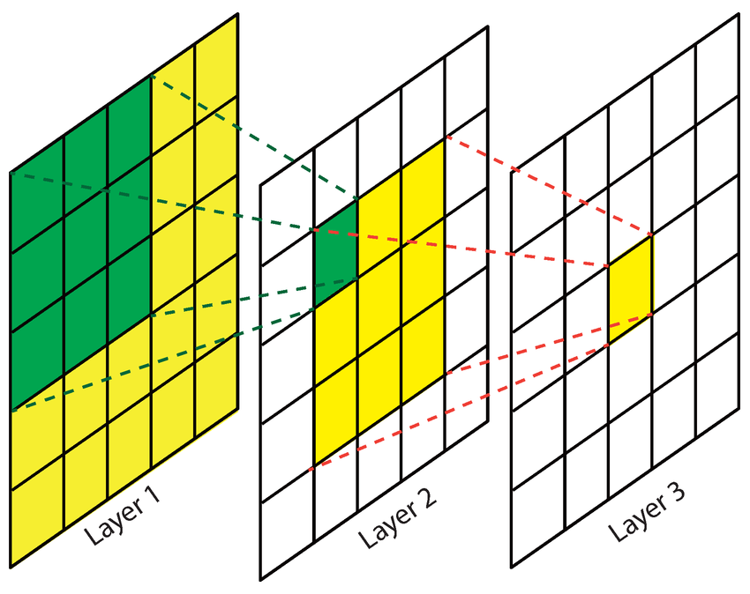gg

* As this network is very deep due to multiple layers, first a shallow network is trained, followed by addition of 4 conv layers and 3 fc layers to complete the training process.
* This was also the first paper to propose a fully convolutional architecture effectively converting last two fc layers into convolutional layers. The first fc layer was converted into 7*7 conv layer and second fc layer to a 1*1 conv layer.